Denormalization and Normalization of Database Tables,
Using Access2000

Denormalization of database tables is sometimes done to facilitate query simplicity and speed. In fact, denormalized database tables are the norm in Data Warehouses, which are information-oriented “snapshot” databases in which transactions do not have the operational focus. Therefore, the data redundancy that is so destructive in the transaction-oriented production database is not a factor in the Data Warehouse environment. Not surprisingly, 2NF is the Data Warehouse’s preferred table structure. For this reason, you should know how to denormalize.

Unfortunately, the 2NF table structure that is quite acceptable in the Data Warehouse’s “snapshot” information-focused environment is also encountered in many production databases. And the data redundancy that characterizes 2NF database tables is potentially devastating to the proper operation of the transaction-heavy databases that characterize the production database environment. Therefore, you need to know how to recognize 2NF structures and you need to know how to transform those 2NF structures into proper 3NF structures. (If you don’t quite remember the normalization terminology and labels such as 2NF and 3NF, review Chapter 2.)

To demonstrate the various normalization and denormalization procedures, let’s first create a new database named Demo-FlyHigh-3, then import the AIRCRAFT and MODEL tables from the FlyHigh-3 database. The two tables are shown in Figures 1 and 2. Note that both tables are in 3NF.

Figure 1 The AIRCRAFT Table
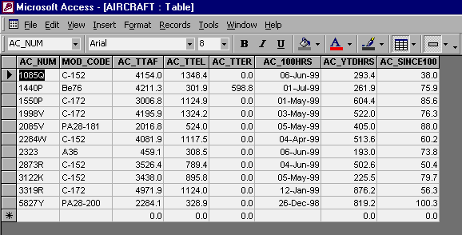

Figure 2 The MODEL Table
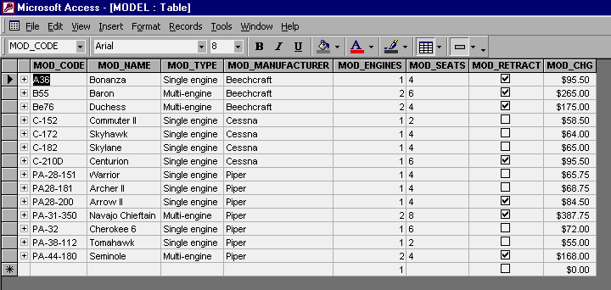

Incidentally, note that the MODEL table contains many more models than you’ll find in the AIRCRAFT table. (AIRCRAFT is optional to MODEL.)

Denormalization With “Make Table” Queries

To demonstrate the normalization procedure, let’s create an aircraft table structure, which we’ll name AIRCRAFT2NF, that contains both the AIRCRAFT table and the MODEL table’s attributes. Clearly, this new table will be in 2NF, because its primary key is AC_NUM, yet MOD_CODE determines the MOD_NAME, MOD_TYPE, and so on.

Figure 3 Creating the 2NF Table Named AIRCRAFT2NF
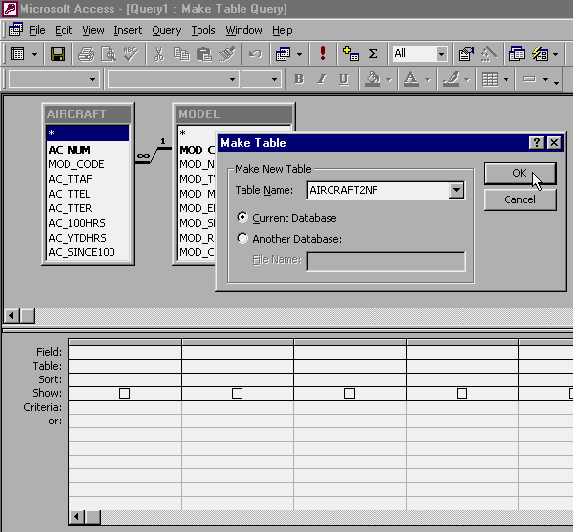

Figure 4 Saving the New Make Table Query
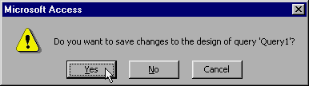

Figure 5 Naming the New Make Table Query
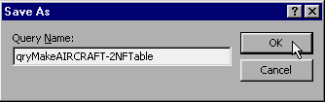

Figure 6 Specifying the Make Table Criteria
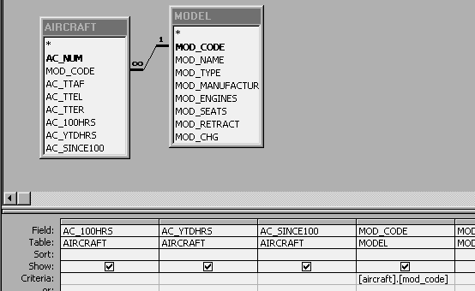

Note the condition: Append the MODEL data only when the MODEL table’s MOD_CODE value is equal to the AIRCRAFT table’s MOD_CODE value. This is important, because the MODEL table contains many more models than are represented in the AIRCRAFT table.

After the new qryMakeAIRCRAFT-2NFTable query has been saved, return to the query window and open the query to create the 2NF table. You will see the warning messages displayed in Figures 7 and 8 to indicate that the query is performing its intended functions. Figure 8 shows that only the eleven AIRCRAFT records are included in the new 2NF table, thus indicating that the criteria statement in Figure 6 is generating the correct results. (Remember that the MODEL table contains many more models than are represented in the AIRCRAFT table!)

Note 1: If you do not see the warning messages shown in Figures 7 and 8, the database default setting must be changed. Use the following procedure to get this job done:

Step 1: Select the Tools/Options
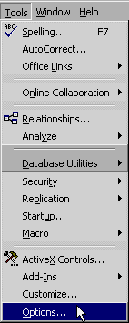

If the entire menu list is not shown, select the Tool/Options shown next, then place the cursor on the double chevrons to generate the rest of the menu.
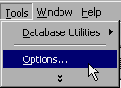

Select the Options to generate the dialog box shown next. Make sure that the Action queries contain a check mark.

Don’t forget to click on the Apply button after you have made your options selection.
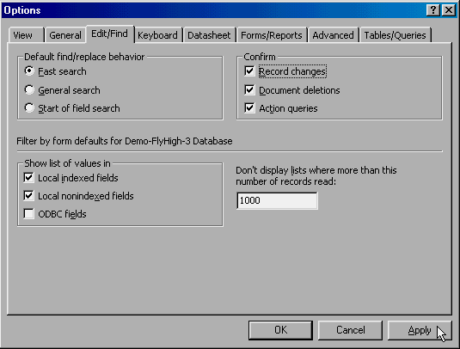

Note 2: If you do not want your final applications to shown the confirmation (warning) messages shown in Figures 7 and 8, use a macro (see Chapter 8 and 9) to get the job done. The macro action will be SetWarnings and its action argument will be No. This macro action will then pertain only to the application that triggered the macro and the database default condition will be maintained at the database level. Do not set the warnings off at the database level!

Figure 7 Running the Make Table Query: Initial Confirmation (Warning) Message
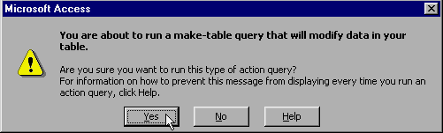

Figure 8 The Make Table Query’s Final Conformation (Warning) Message
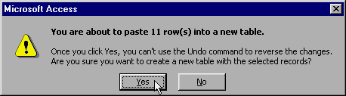

After the Make Table query has been run, open the newly created AIRCRAFT2NF table to check its contents. Figure 9 shows the results.
Figure 9 The Newly-Created AIRCRAFT2NF Table in 2NF Normal Form
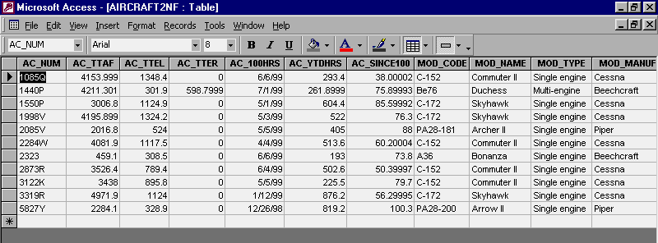

As you examine Figure 9, note that the formatting that was used in the original AIRCRAFT and MODEL tables is lost. The new table uses the Access default format for all of its attributes (fields.) For example, if you examine the AIRCRAFT table shown in Figure 1, you can see that the AIRCRAFT table’s AC_SINCE100 numeric format was originally set at one decimal place, its AC_100HRS date format was originally set at dd-mmm-yyyy, and so on. However, what’s more important at this point is the fact that the 2NF format has been generated properly.

Note 3: Because the AIRCRAFT2NF table contains so many attributes, the table is too wide to fit on the screen and you’ll have to use the scroll bar to see the remaining attributes. The screen capture shown in Figure 9 shows the first eleven attributes.

Normalizing a 2NF Table To a Set of 3NF Tables

Now you know how to denormalize a table, changing it from a 3NF set of tables to one 2NF table. But how do you normalize a 2NF table to 3NF? That job, too, requires the use of Make Table queries. Let’s use Figure 9’s AIRCRAFT2NF table as the basis for this procedure.

To avoid replacing the original AIRCRAFT and MODEL tables, we’ll name the normalized tables AIRCRAFT2 and MODEL2, respectively. To make the process self-documenting, let’s make sure that the Make Table query names reflect their function, so we’ll name them

qryMakeAIRCRAFT2-3NFTable

and

qryMakeMODEL2-3NFTable

Figures 10 and 11 show the basic make-up of each of the two queries. Review Figures 1 through 5 to see the basic Make Table query construction process. (If necessary, review Chapter 5.)

Figure 10

Start

